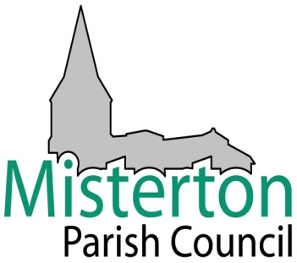

Filming of Public Meetings
Information on filming, recording and taking photographs at Council meetings that are open to the public

Misterton Parish Council supports the principle of transparency and encourages filming, recording and taking photographs at its meetings that are open to the public. It also welcomes the use of social networking websites (such as Twitter and Facebook) and micro-blogging to communicate with people about what is happening at a meeting.

There is no requirement to notify the Council in advance, but it should be noted that the Chairman of the meeting will have absolute discretion to terminate or suspend any of these activities if, in their opinion, continuing to do so would prejudice proceedings at the meeting.

The circumstances in which termination or suspension might occur could include:
- public disturbance or suspension of the meeting
- the meeting agreeing to formally exclude the press and public from the meeting due to the confidential nature of the business being discussed where it is considered that continued recording/photography/filming/webcasting might infringe the rights of any individual or otherwise disrupt proceedings
- when the Chairman considers that a defamatory statement has been made

It is expected that those recording meetings will not edit any film/recording/photographs in a way that could lead to misinterpretation or misrepresentation of the proceedings. This includes refraining from editing an image or views expressed in a way that may ridicule, or show a lack of respect towards those being photographed/filmed/recorded.

Those intending to bring large equipment or wishing to discuss any special requirements are advised to contact the Clerk to the Council in advance of the meeting to seek advice and guidance. Please note that such requests will be subject to practical considerations and the constraints of specific meeting rooms.

The use of flash photography or additional lighting will not be allowed unless this has been discussed in advance of the meeting and agreement reached on how it can be done without disrupting proceedings. This can be done via the Clerk to the Council on 01427 891659 or theclerk@misterton-notts-pc.gov.uk soon as possible before the scheduled meeting is due to take place.

At the beginning of each meeting, the Chairman will make an announcement that the meeting may be filmed, recorded or photographed. Meeting agendas will also carry this message.

Council Agendas
The following will be included in all Council agendas:
In accordance with Regulation 4(6) of the Local Authorities (Executive Arrangements) (Meetings and Access to Information) (England) Regulations 2012, audio/visual recording and photography at Council meetings is permitted in accordance with the Council’s protocol “Filming of Public Meetings.”

