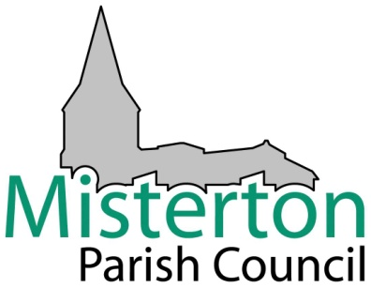

HEALTH AND SAFETY POLICY
1. GENERAL STATEMENT
Misterton Parish Council is committed to providing a safe and healthy environment and that all activities carried out by its undertaking, are coordinated effectively to ensure that any risks to health and safety meet our minimum common and statutory health and safety responsibilities as far as is reasonably practicable. Furthermore, the Council recognises and accepts its responsibilities as an employer for providing a safe and healthy working environment for all its employees, contractors, volunteers and others who may be affected by the activities of the Council.
The Council will endeavour to meet its responsibilities under the Health and Safety at Work etc Act 1974, and will provide as far as is reasonably practicable, the resources necessary to fulfil its commitment.
The Council will obtain as and when appropriate, professional advice on Health and Safety to assist the Clerk in fulfilling the Council’s responsibilities for ensuring safe working conditions.
2. HEALTH AND SAFETY POLICY AIMS
The Council will so far as is reasonably practicable provide:

2.1 and maintain safe plant, equipment and systems at work;
2.2 safe arrangements for the use, handling, storage and transport of articles of substance;
2.3 suitable information, instruction and training to enable its employees to avoid risks to their own and the health and safety of others at work;
2.4 specialist technical advice and assistance on matters of Health and Safety where necessary;

2.5 a healthy working environment including the provision of protective clothing where appropriate;
2.6 care and attention to the health, safety and welfare of employees, contractors, volunteers and members of the public who may be affected by the council’s activities.

3. ARRANGEMENTS AND RESPONSIBILITIES FOR CARRYING OUT THE HEALTH AND SAFETY POLICY
3.1 All employees, contractors and volunteers are expected to:

3.1.1 Ensure they take reasonable care of their own health and safety;

3.1.2 Ensure that they do not put at risk the safety of anyone else who may be affected by the work they are carrying out or recklessly interfere with or misuse anything provided in the interest of health, safety and welfare;

3.1.3. Co-operate with Misterton Parish Council to enable compliance with all statutory and council duties;

3.1.4 Not to initiate, or continue, any process or activity that places employees, or others, in danger, or is in breach of statutory obligations with respect to health and safety;

3.1.5 Report any accidents, incidents, concerns, hazard or defect to the Clerk

3.1.6 Ensure that they wear appropriate protective clothing and use correctly any tools and equipment provided.
  - The Clerk to the Council will:
3.2.1 Make arrangements for the implementation of the Councils Health and Safety Policy;
3.2.2 Inform the Council of any resources and arrangements necessary to fulfil the Council’s responsibilities under the Health and Safety Policy;
    - Act as the contact and liaison point for the Health and Safety Executive;
    - Retain and maintain a central record of accidents;
    - Make effective arrangements to ensure that those contractors or voluntary helpers working for the Council comply with all reasonable health and safety requirements;
    - Ensure that any relevant health and safety issues are discussed at meetings of the Council;
    - When notified or become aware of an accident or hazardous incident, take immediate action to prevent a reoccurrence or further accident and to complete the necessary accident report;

